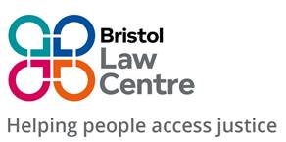

BRISTOL LAW CENTRE

Person Specification

Immigration Caseworker / Solicitor

The successful applicant will be able to demonstrate the following skills, abilities or experience:

Essential

- An ability to manage a caseload and to prioritise effectively working under pressure

- Proven ability to deal sensitively and with empathy, with clients who may be distressed, while communicating effectively in order to give and receive key information.

- An understanding of the role and function of Bristol Law Centre, commitment to its values and to the Law Centre's Equality and Diversity Policy

- A commitment to team working, including working to share knowledge and learning in order to continuously improve ways of working and client outcomes

- Experience of working in partnership with external organisations

- Experience of working to targets and to defined outcomes

- Experience of working with case management systems to capture and record time.

Desirable

- Level 3 OISC or IAAS Senior Caseworker accreditation or above

- Three years’ experience of immigration and asylum casework, which should include at least 2 years working at Senior Caseworker/Solicitor level

- A good understanding of the current issues in immigration and asylum law

- Experience of carrying out LAA funded work in immigration and asylum (including certificated work)

- Advocacy experience in Immigration Tribunals, including Upper Tribunal

- Experience of working with children and young people

- Experience of Trauma-Informed Legal Practice

